CS676A - Assignment 1

Mean Shift Based Segmentation

Shubham Jain - 13683

Vikas Jain - 13788

Two type of kernels for the segmentation are used:

1. **Gaussian Kernel**kernel function
2. **Flat Kernel**  
   kernel function

To merge modes, we first found out the modes with less than 40 pixel and then merged it with the nearest mode based on the colour and position distance.

Complete assignment and all result images are available on the drive - <https://drive.google.com/folderview?id=0B1Y4inhbx3CzZk5SNGgxblBoUGs&usp=sharing>

1. Gaussian Kernel:

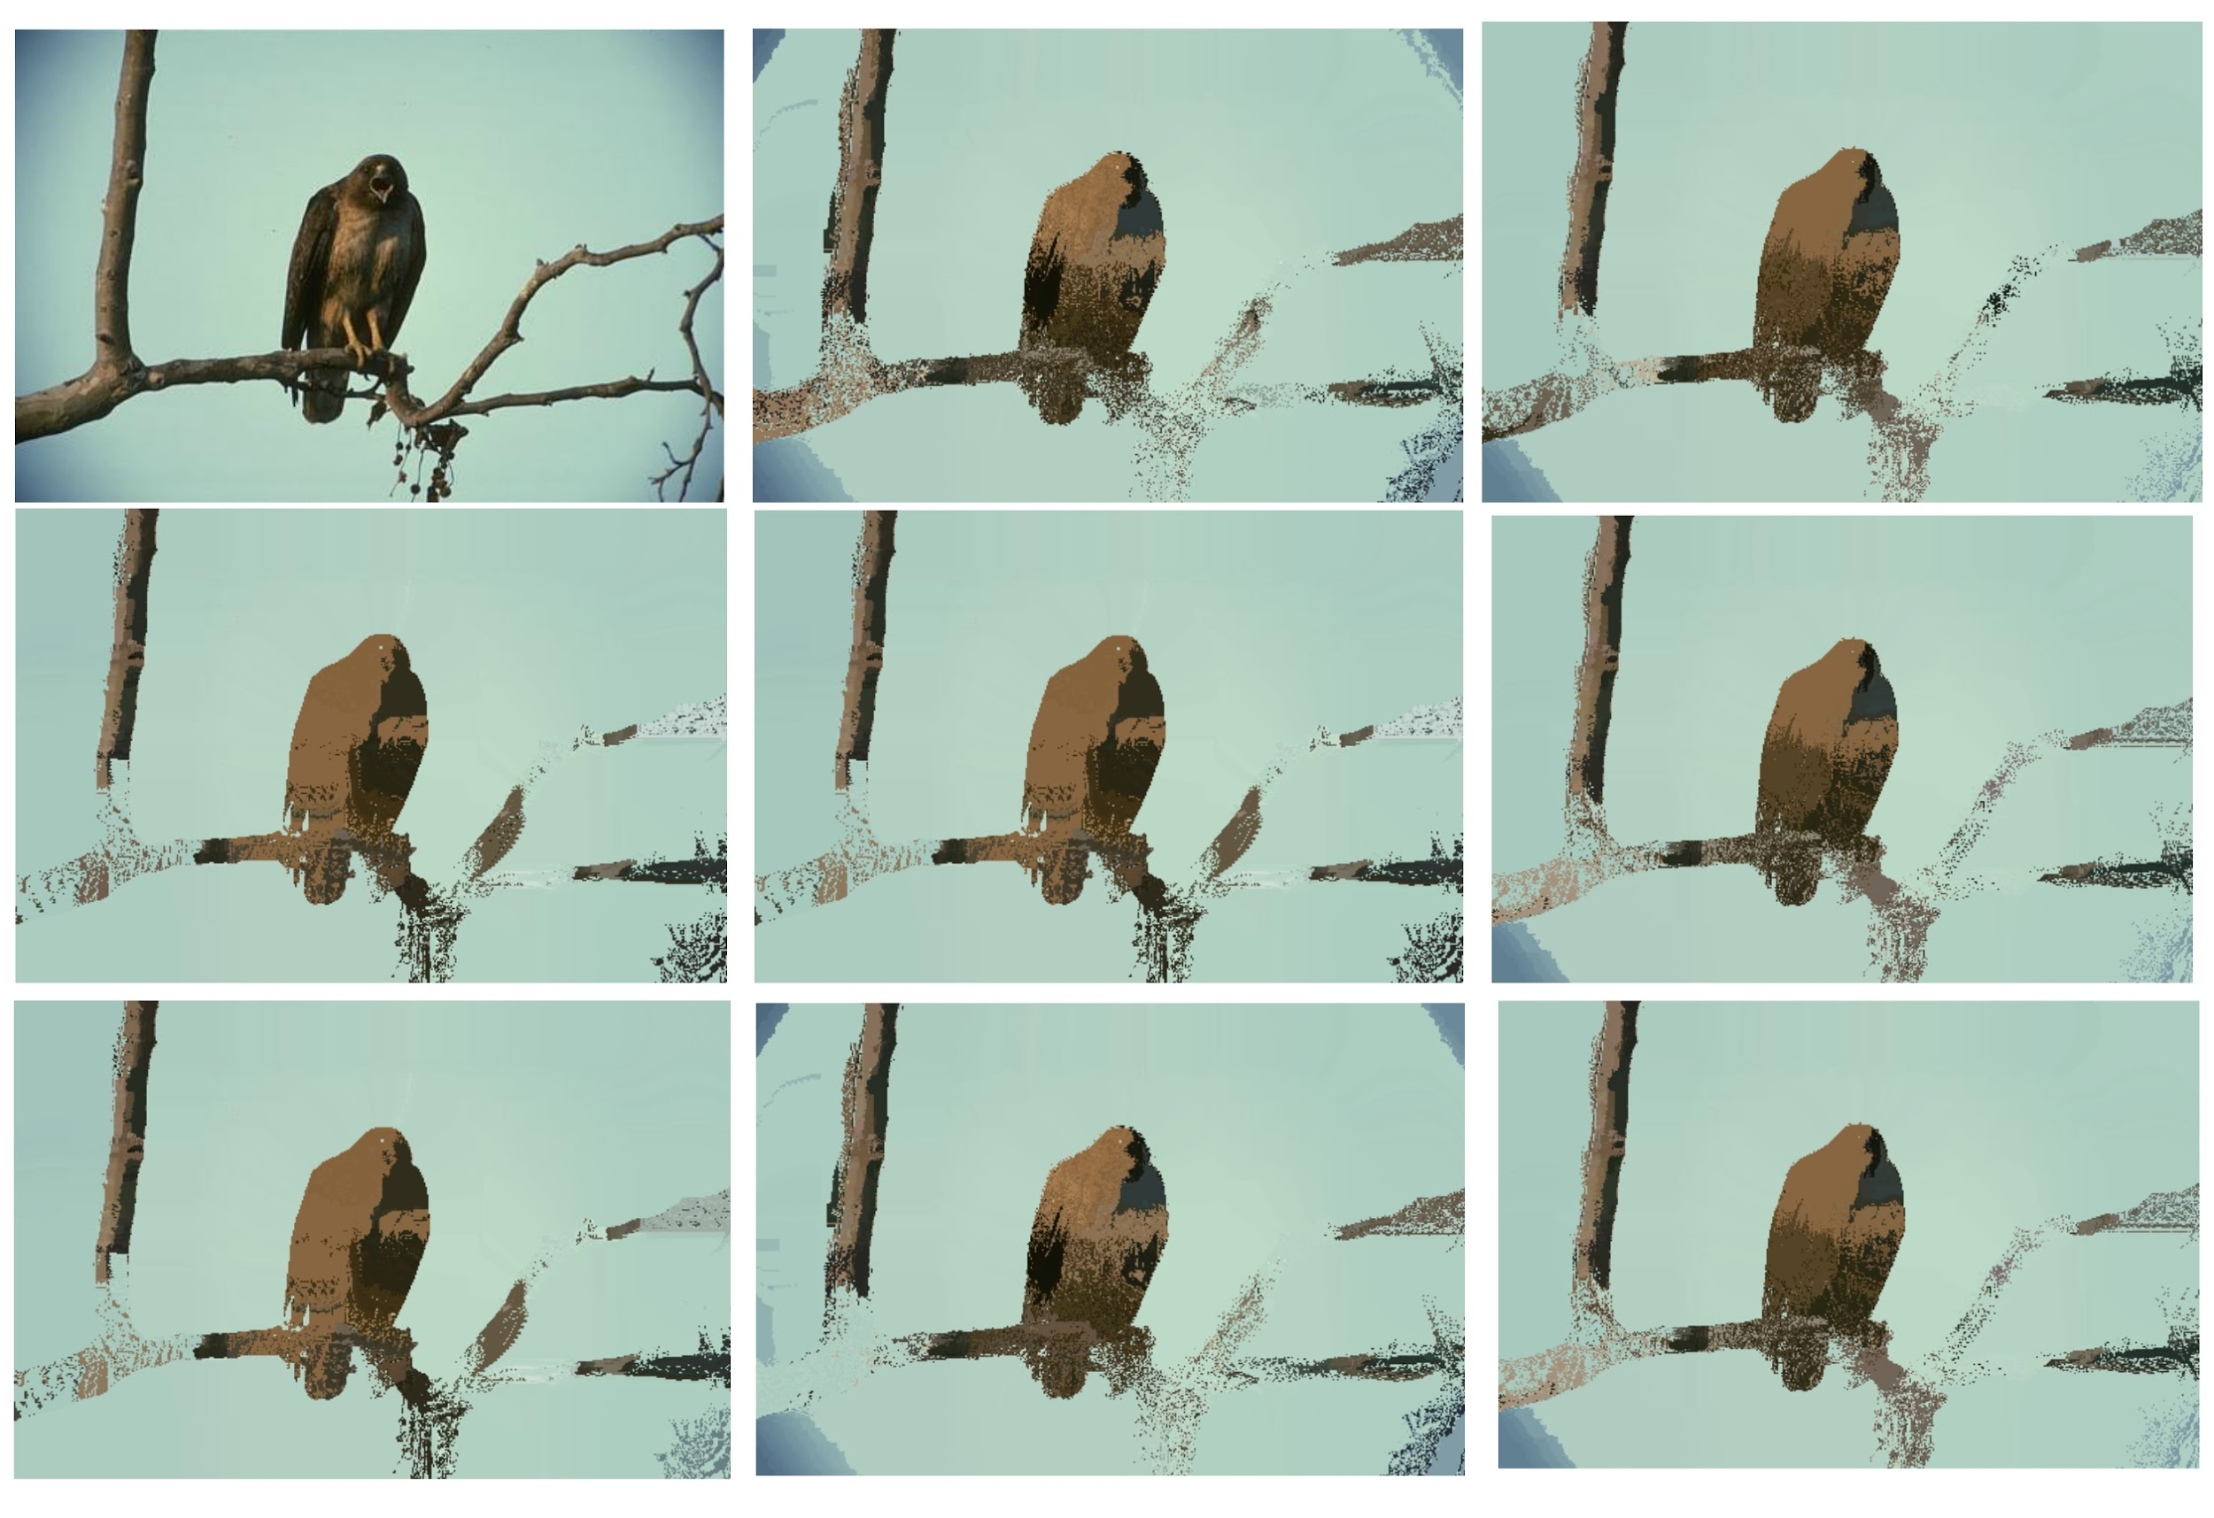

*Kernel bandwidth value (ks,kc) (left to right then top to down order):*

*(10,10), (10,15), (15,30), (20,30), (35,15), (35,30), (50,10), (50,15)*

|  |  |  |  |
| --- | --- | --- | --- |
| **kernel_hs** | **kernel_hc** | **Modes before merging** | **Modes after merging** |
| 10 | 10 | 10459 | 1238 |
| 10 | 15 | 14616 | 1282 |
| 10 | 20 | 16180 | 1358 |
| 10 | 25 | 16810 | 1436 |
| 10 | 30 | 17312 | 1503 |
| 15 | 30 | 17261 | 1493 |
| 15 | 35 | 17635 | 1543 |
| 20 | 25 | 16755 | 1440 |
| 20 | 30 | 17244 | 1484 |
| 20 | 35 | 17608 | 1535 |
| 35 | 15 | 14501 | 1275 |
| 35 | 20 | 16104 | 1352 |
| 35 | 25 | 16741 | 1428 |
| 35 | 30 | 17227 | 1483 |
| 45 | 20 | 16102 | 1354 |
| 45 | 25 | 16738 | 1429 |
| 45 | 30 | 17226 | 1484 |
| 50 | 10 | 10348 | 1232 |
| 50 | 15 | 14494 | 1271 |
| 50 | 20 | 16099 | 1353 |

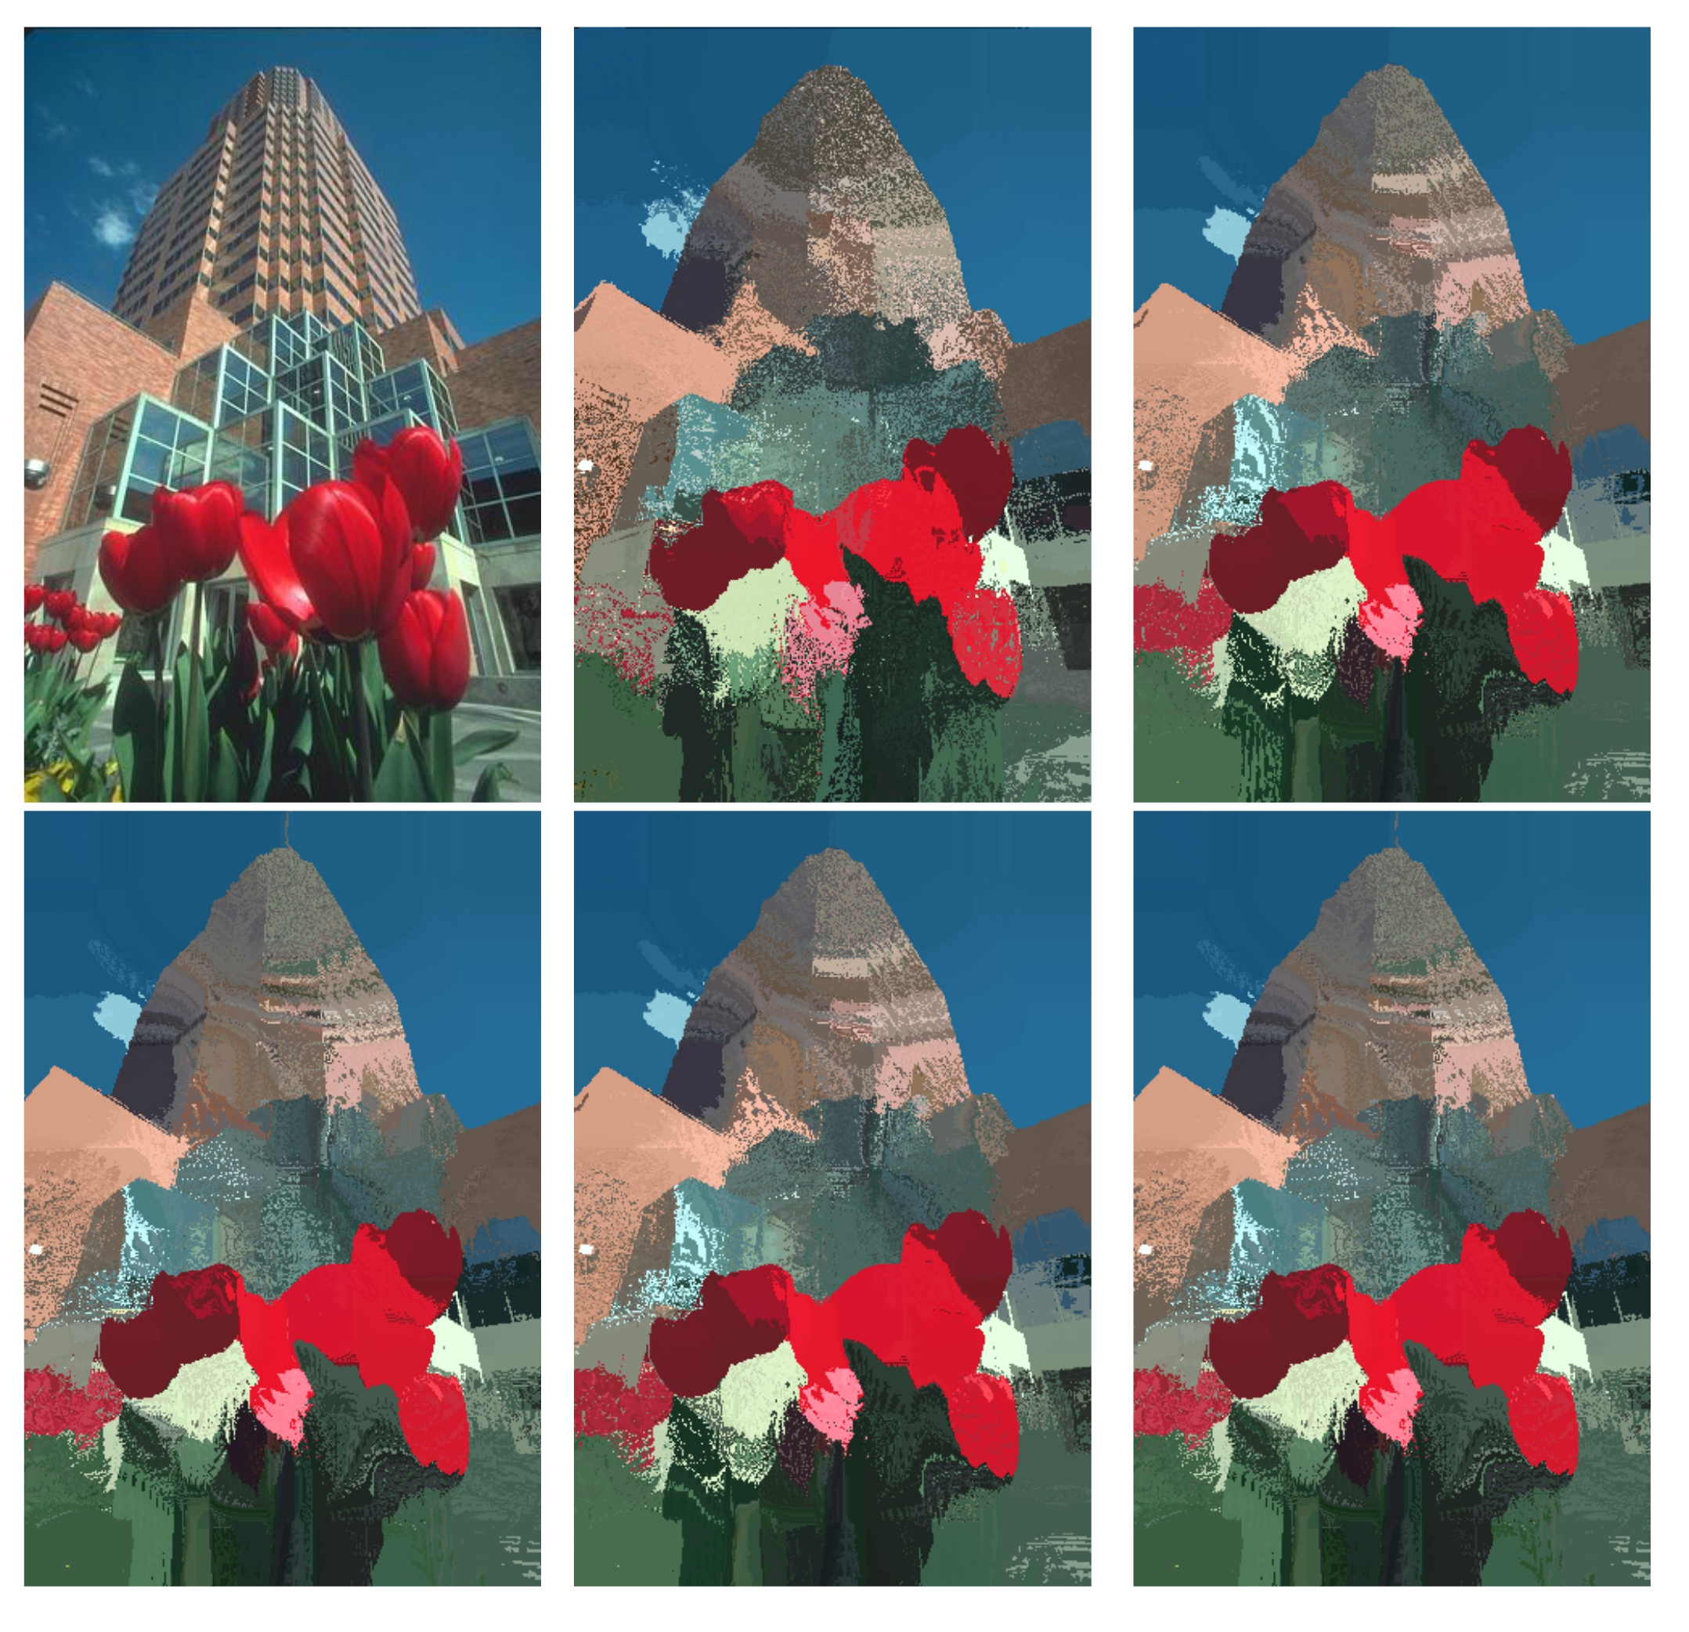

*Kernel bandwidth value (ks,kc) (left to right then top to down order) :*

*(10,20), (10,30), (15,30), (15,35), (20,30)*

|  |  |  |  |
| --- | --- | --- | --- |
| **kernel_hs** | **kernel_hc** | **Modes before merging** | **Modes after merging** |
| 10 | 10 | 2185 | 842 |
| 10 | 15 | 3018 | 877 |
| 10 | 25 | 3702 | 957 |
| 10 | 20 | 3406 | 918 |
| 10 | 30 | 3983 | 1002 |
| 10 | 35 | 4435 | 1061 |
| 15 | 30 | 3933 | 991 |
| 15 | 35 | 4401 | 1059 |
| 20 | 25 | 3634 | 926 |
| 20 | 30 | 3929 | 994 |
| 20 | 35 | 4396 | 1057 |
| 35 | 15 | 3005 | 862 |
| 35 | 20 | 3371 | 918 |
| 35 | 25 | 3613 | 923 |
| 35 | 30 | 3918 | 992 |
| 45 | 20 | 3370 | 919 |
| 45 | 25 | 3610 | 921 |
| 45 | 30 | 3917 | 994 |
| 50 | 10 | 2161 | 824 |
| 50 | 15 | 3003 | 862 |
| 50 | 20 | 3371 | 919 |

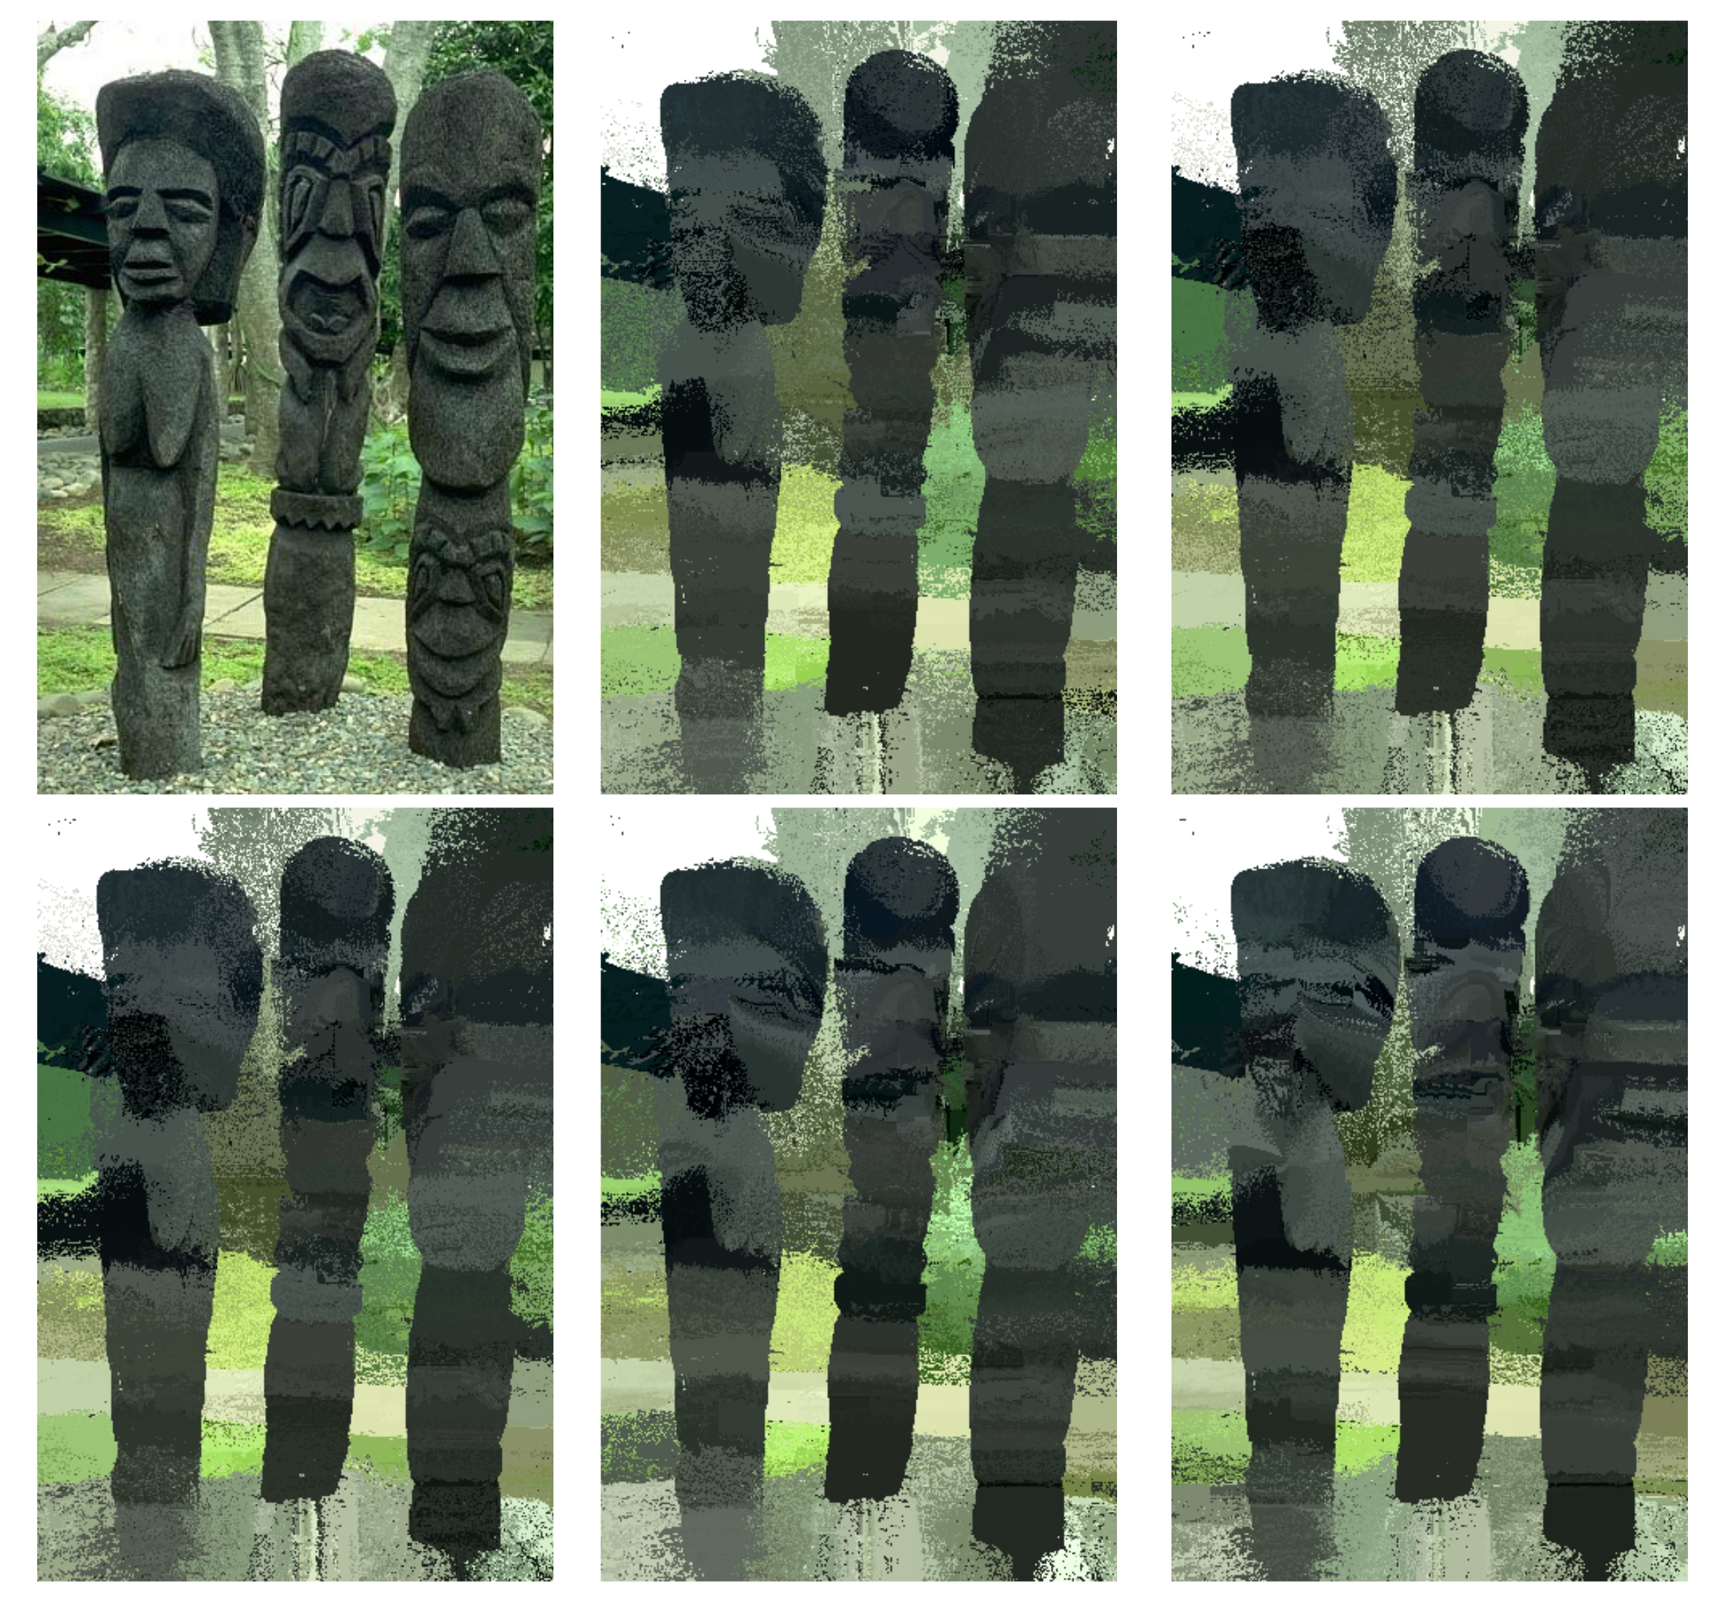

*Kernel bandwidth value (ks,kc) (left to right then top to down order) :*

*(10,25), (10,30), (10,40), (20,30), (35,20)*

|  |  |  |  |
| --- | --- | --- | --- |
| **kernel_hs** | **kernel_hc** | **Modes before merging** | **Modes after merging** |
| 10 | 10 | 1465 | 707 |
| 10 | 15 | 1741 | 747 |
| 10 | 20 | 2037 | 778 |
| 10 | 25 | 2350 | 825 |
| 10 | 30 | 2780 | 944 |
| 10 | 35 | 3351 | 1027 |
| 10 | 40 | 3904 | 1064 |
| 10 | 45 | 4569 | 1169 |
| 15 | 30 | 2774 | 938 |
| 15 | 35 | 3349 | 1041 |
| 20 | 25 | 2338 | 812 |
| 20 | 30 | 2766 | 938 |
| 20 | 35 | 3347 | 1045 |
| 35 | 15 | 1725 | 745 |
| 35 | 20 | 2016 | 781 |
| 35 | 25 | 2336 | 813 |
| 35 | 30 | 2759 | 932 |
| 45 | 20 | 2012 | 780 |
| 45 | 25 | 2334 | 815 |
| 45 | 30 | 2758 | 931 |
| 50 | 10 | 1442 | 691 |
| 50 | 15 | 1720 | 742 |
| 50 | 20 | 2012 | 780 |

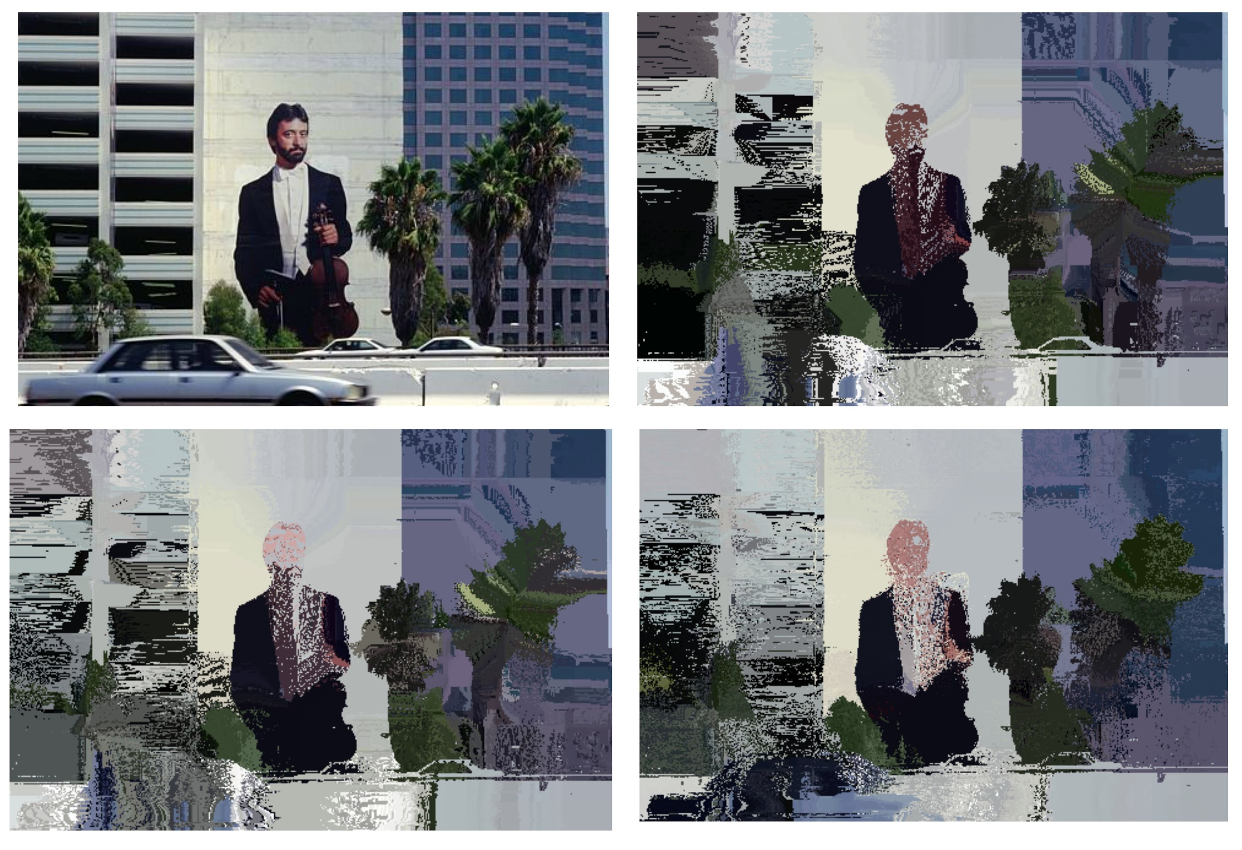

*Kernel bandwidth value (ks,kc) (left to right then top to down order) :*

*(10,40), (50,15), (10,35)*

|  |  |  |  |  |  |
| --- | --- | --- | --- | --- | --- |
| **kernel_hs** | **kernel_hc** | **Modes before merging** | **Modes after merging(min number of modes >20)** | **Modes after merging (min modes >30)** | **Modes after merging (min modes >40)** |
| 10 | 10 | 1768 | 732 | 643 | 590 |
| 10 | 15 | 2166 | 875 | 739 | 654 |
| 15 | 30 | 2921 | 966 | 799 | 703 |
| 15 | 35 | 3359 | 1061 | 873 | 761 |
| 20 | 25 | 2649 | 944 | 763 | 683 |
| 20 | 30 | 2906 | 968 | 797 | 703 |
| 20 | 35 | 3350 | 1059 | 872 | 761 |
| 35 | 15 | 2143 | 845 | 724 | 635 |
| 35 | 20 | 2429 | 911 | 758 | 670 |
| 35 | 25 | 2642 | 938 | 760 | 683 |

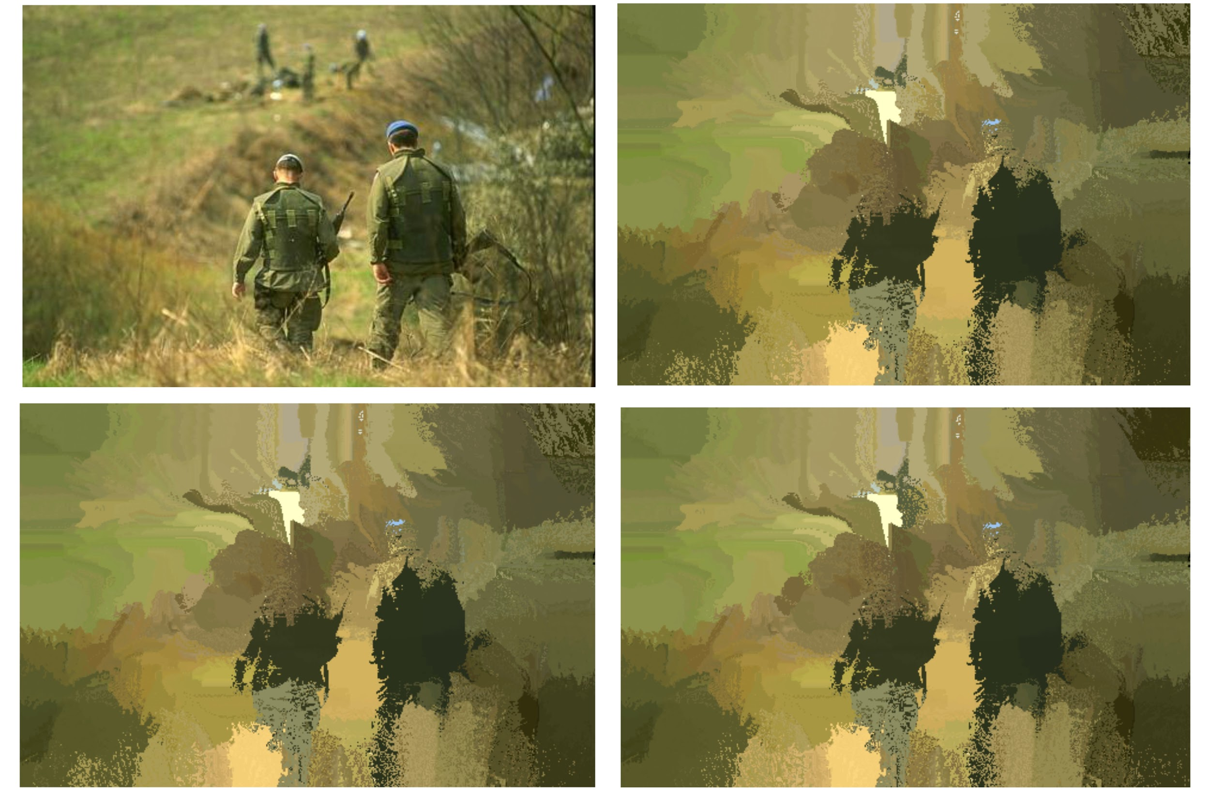

*Kernel bandwidth value (ks,kc) (left to right then top to down order):  
 (10,30), (35,30), (45,30)*

|  |  |  |  |
| --- | --- | --- | --- |
| **kernel_hs** | **kernel_hc** | **Modes before merging** | **Modes after merging** |
| 10 | 10 | 1526 | 609 |
| 10 | 15 | 2262 | 748 |
| 10 | 20 | 3053 | 866 |
| 10 | 25 | 4018 | 977 |
| 10 | 30 | 5249 | 1103 |
| 10 | 35 | 6581 | 1245 |
| 10 | 40 | 8273 | 1407 |
| 15 | 30 | 5218 | 1111 |
| 15 | 35 | 6549 | 1234 |
| 20 | 25 | 3993 | 989 |
| 20 | 30 | 5202 | 1106 |
| 20 | 35 | 6544 | 1231 |
| 35 | 15 | 2248 | 743 |
| 35 | 20 | 3029 | 859 |
| 35 | 25 | 3987 | 985 |
| 35 | 30 | 5191 | 1101 |
| 45 | 20 | 3029 | 857 |
| 45 | 25 | 3987 | 982 |
| 45 | 30 | 5189 | 1104 |
| 50 | 10 | 1501 | 592 |
| 50 | 15 | 2249 | 743 |
| 50 | 20 | 3027 | 856 |

**Flat Kernel Results:**

1. **Image 42049.jpg**

|  |  |  |
| --- | --- | --- |
| Bandwidth (h) | no. of modes before mode merging | no. of modes after mode merging |
| 30 | 833 | 421 |
| 40 |  |  |
| 50 | 910 | 445 |
| 60 | 917 | 456 |
| 70 | 939 | 441 |

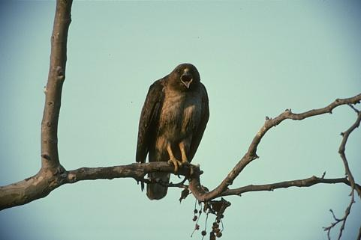

*Original Image*

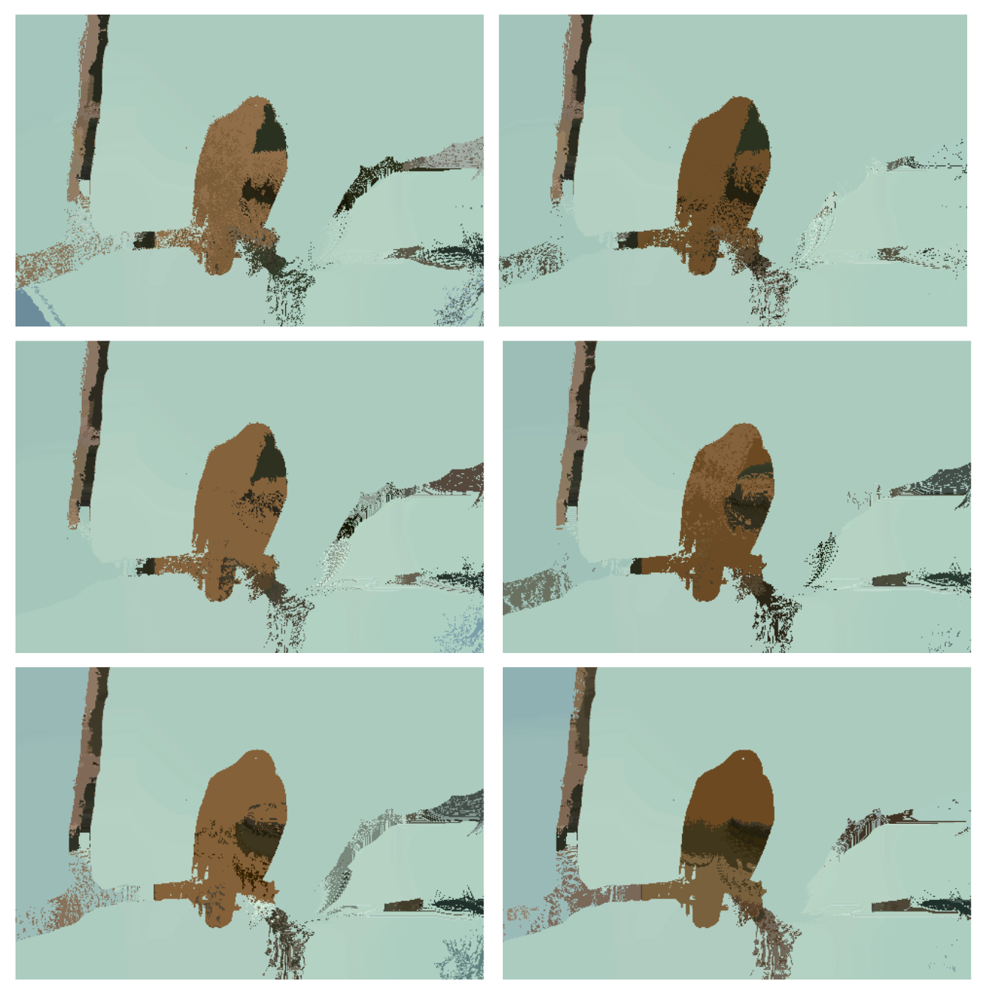

*Segmented Images*

*Kernel bandwidth value (left to right then top to down order) 30, 35, 40, 50, 60, 70*

1. **Image 86000.jpg**

|  |  |  |
| --- | --- | --- |
| Bandwidth (h) | no. of modes before mode merging | no. of modes after mode merging |
| 30 | 447 | 291 |
| 40 |  |  |
| 50 | 607 | 322 |
| 60 | 608 | 316 |
| 70 | 737 | 353 |

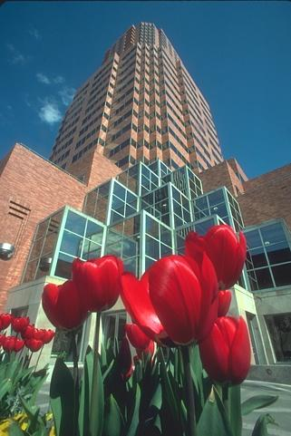

*Original Image*

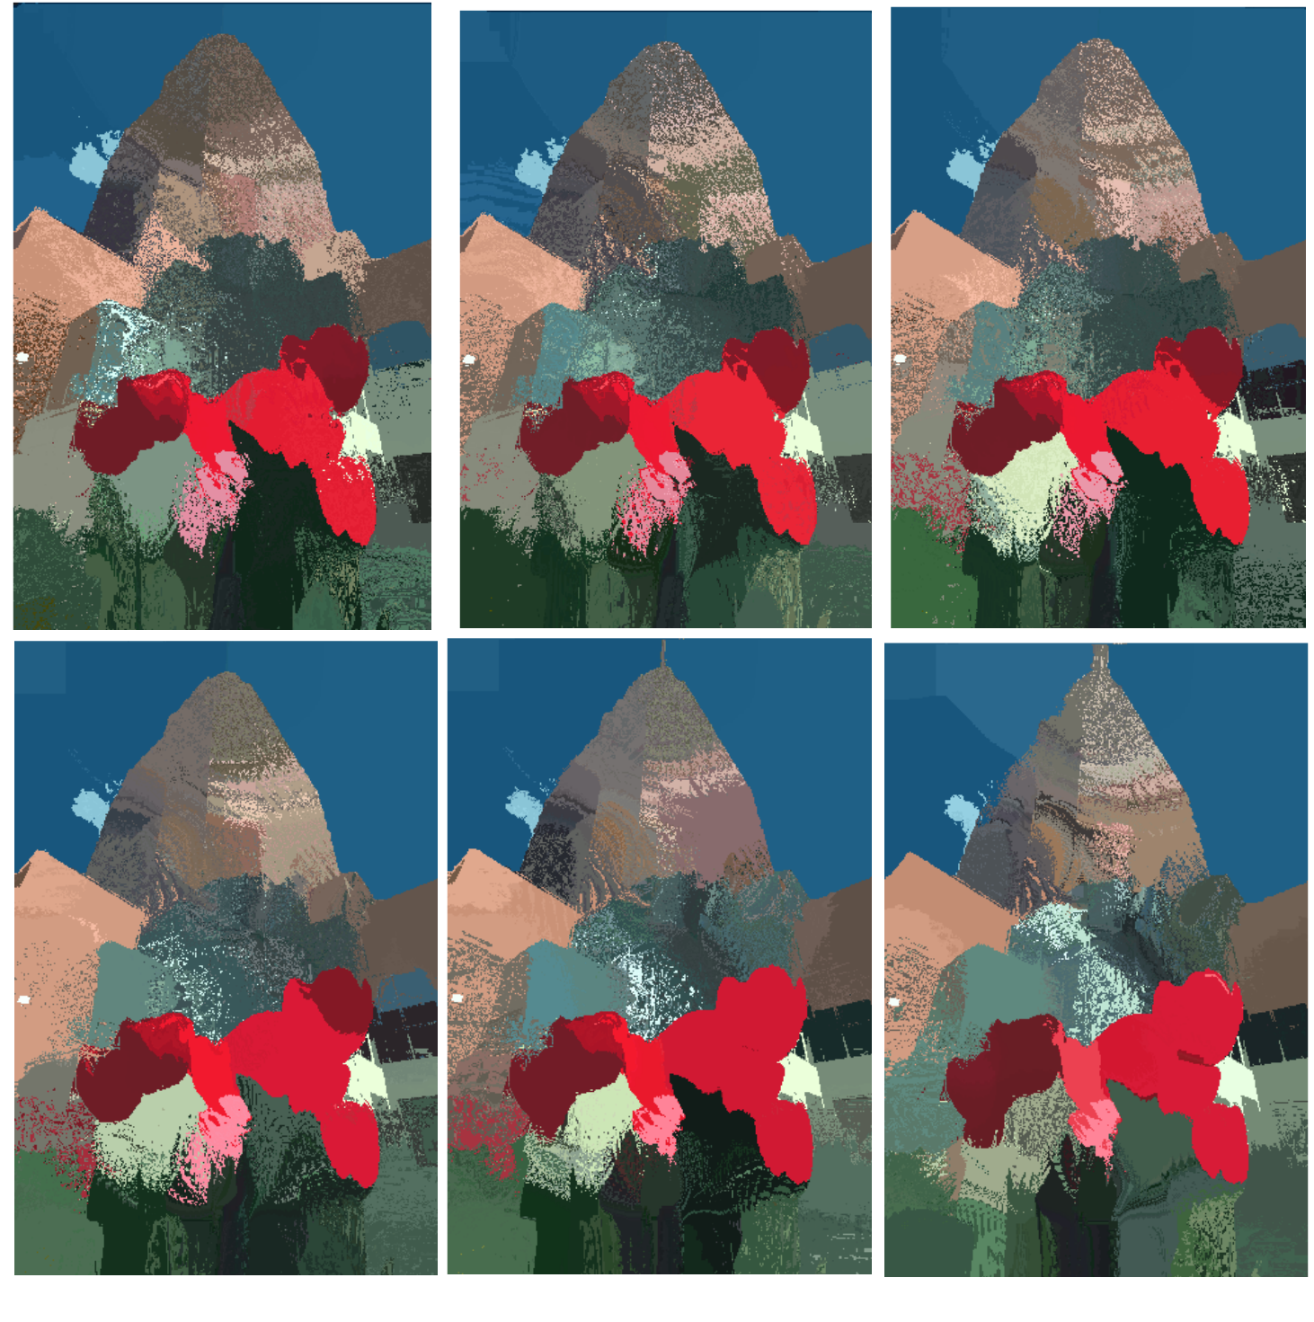

*Segmented Images*

*Kernel bandwidth value (left to right then top to down order) 30, 35, 40, 50, 60, 70*

1. **Image 101085.jpg**

|  |  |  |
| --- | --- | --- |
| Bandwidth (h) | no. of modes before mode merging | no. of modes after mode merging |
| 30 | 571 | 329 |
| 40 | 601 | 336 |
| 50 | 910 | 445 |
| 60 | 901 | 425 |
| 70 | 1022 | 448 |

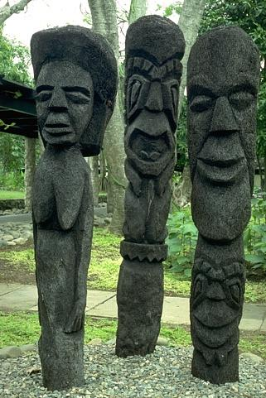

*Original Image*

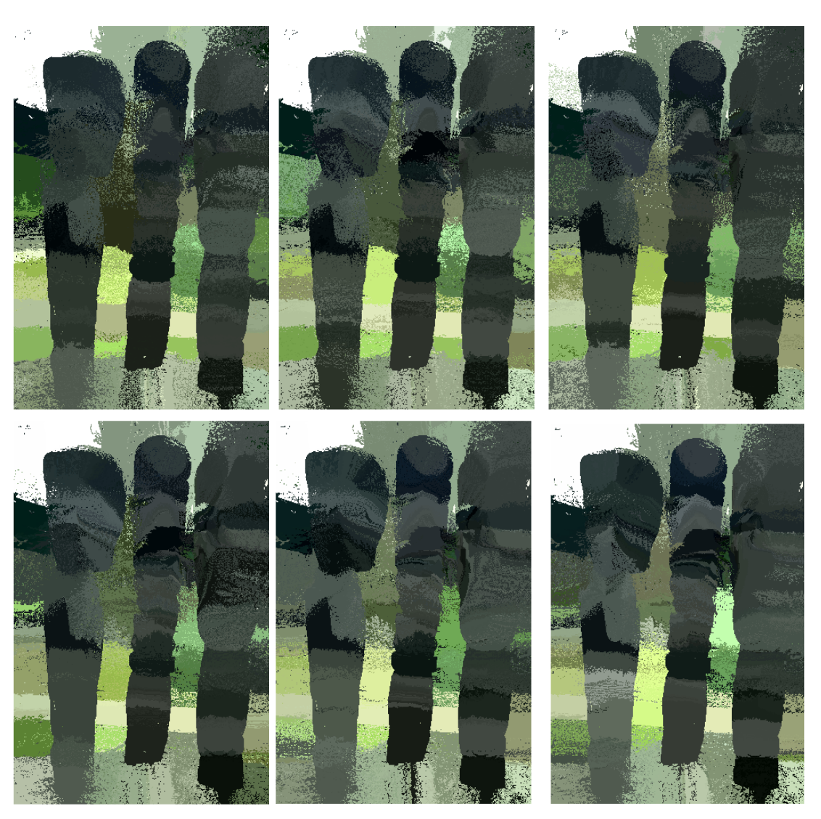

*Segmented Images*

*Kernel bandwidth value (left to right then top to down order) 30, 35, 40, 50, 60, 70*

1. **Image 119082.jpg**

|  |  |  |
| --- | --- | --- |
| Bandwidth (h) | no. of modes before mode merging | no. of modes after mode merging |
| 30 | 587 | 372 |
| 40 |  |  |
| 50 | 747 | 367 |
| 60 | 847 | 395 |
| 70 | 933 | 407 |

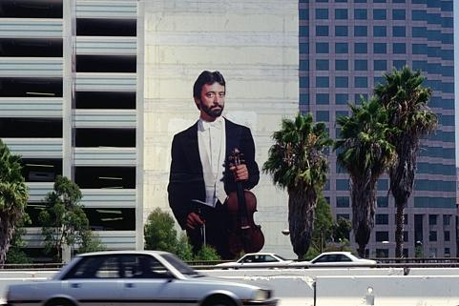  
 *Original Image*

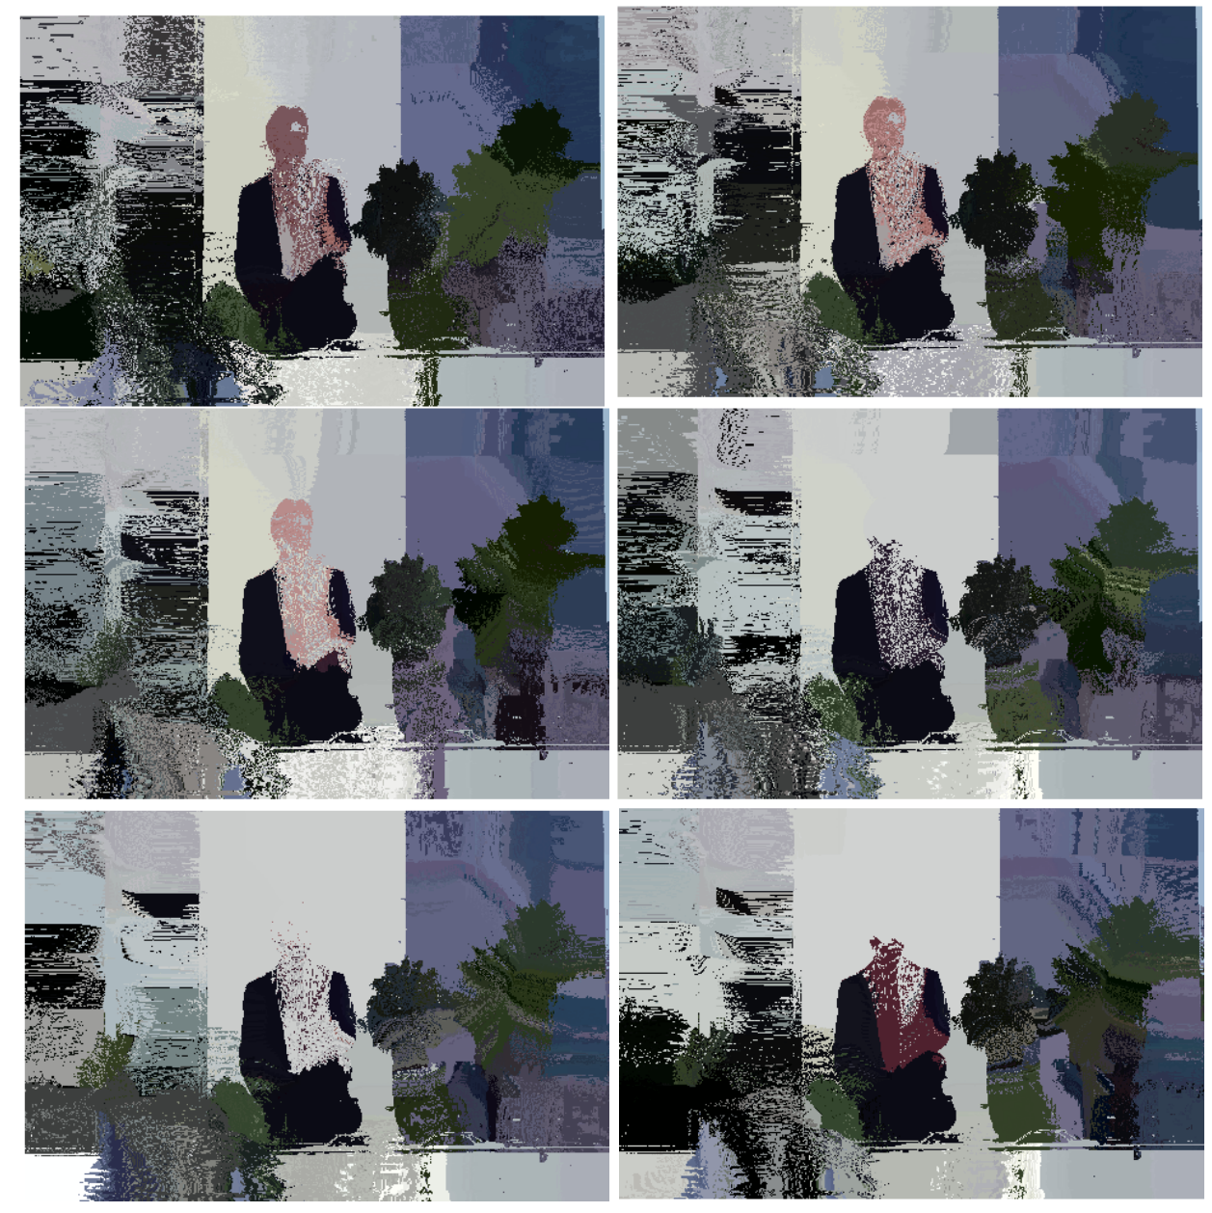

*Segmented Images*

*Kernel bandwidth value (left to right then top to down order) 30, 35, 40, 50, 60, 70*

1. **Image 170057.jpg**

|  |  |  |
| --- | --- | --- |
| Bandwidth (h) | no. of modes before mode merging | no. of modes after mode merging |
| 30 | 811 | 364 |
| 40 |  |  |
| 50 | 1067 | 374 |
| 60 | 1152 | 405 |
| 70 | 1164 | 376 |

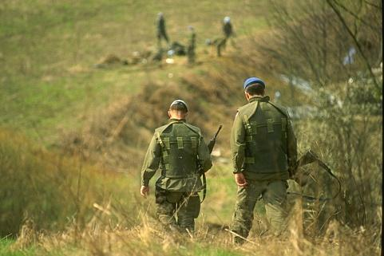

*Original Image*

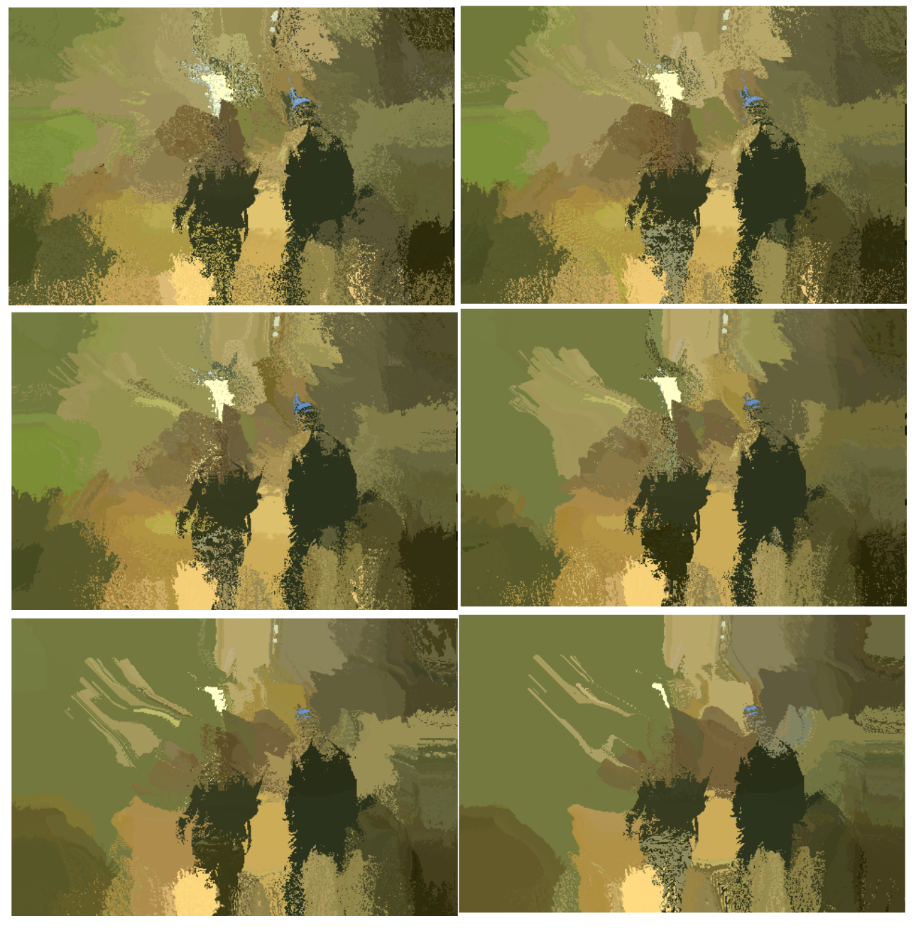

*Segmented Images*

*Kernel bandwidth value (left to right then top to down order) 30, 35, 40, 50, 60, 70*